Wind Lab
Wind is created by the movement of air from areas of high atmospheric pressure to areas of low atmospheric pressure across the planet. Wind speeds are determined by the change in air pressure, with the fastest winds being generated by a rapid change in pressure over a short horizontal distance. Read the following Wind Lab Supplement to learn more about wind, air circulation patterns, and how wind is displayed on weather maps.


Isobar Maps
Isobar maps are maps of air pressure that connect areas with the same pressure with lines called isobars (iso- means "same" and "bars" refers to the measure of air pressure in millibars). The following image is of an isobar map of the United States. Use this map to answer the following questions.

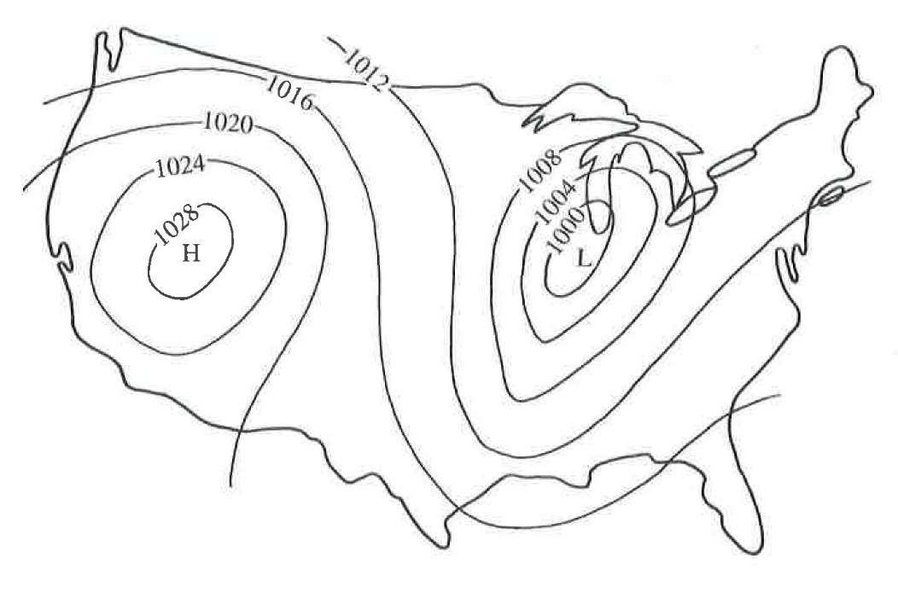
- What is the direction of wind movement (clockwise or counter-clockwise) coming out of the high pressure cell in the western United States?
- What is the direction of wind movement (clockwise or counter-clockwise) coming out of the low pressure cell in the eastern United States?
- What is the predominant direction of wind movement (south to north, north to south, west to east, east to west) across the entire United States?

Answer here:

Wind Lab Answer Worksheet

Isobar Maps

1. Clockwise direction

2. Counterclockwise direction

3. West to East

